

In-Sight"

uoáei1ss0i/sExsansisnuoáuie

Installationanáneferenceuanual

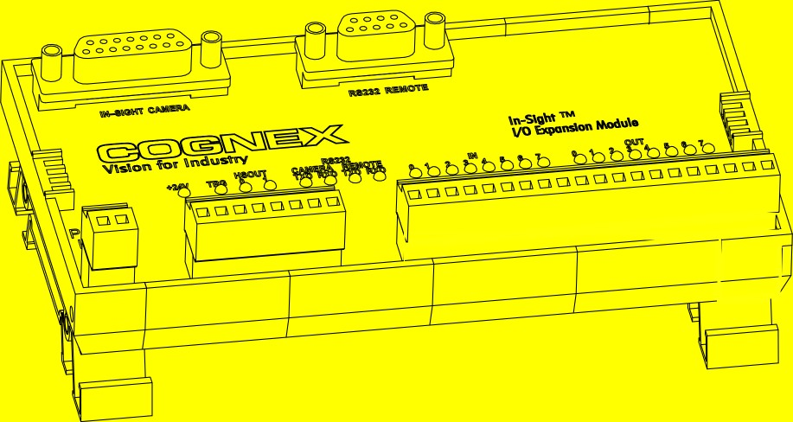

**Copyright, Trademarks, Patents**

The software described in this document is furnished under license, and may be used or copied only in accordance with the terms of such license and with the inclusion of the copyright notice shown on this page. The software, this document, nor any copies thereof may be provided to or otherwise made available to anyone other than the licensee. Title to and ownership of this software remains with Cognex Corporation or its licensor. Cognex Corporation assumes no responsibility for the use or reliability of its software on equipment that is not supplied by Cognex Corporation. Cognex Corporation makes no warranties, either express or implied, regarding the described software, its merchantability or its fitness for any particular purpose.

The information in this document is subject to change without notice and should not be construed as a commitment by Cognex Corporation. Cognex Corporation is not responsible for any errors that may be present in either this document or the associated software.

This document may not be copied in whole or in part, nor transferred to any other media or language, without the written permission of Cognex Corporation.

Cognex P/N 597-0013-05

Copyright © 2004-2005 Cognex Corporation. All Rights Reserved.

The hardware and portions of the software described in this document may be covered by one or more of the following U.S. patents (other U.S. and foreign patents are pending):

Hardware 4,972,359; 5,526,050; 5,657,403; 5,793,899

Vision Tools 5,495,537; 5,548,326; 5,583,954; 5,602,937; 5,640,200; 5,717,785; 5,742,037; 5,751,853;

5,768,443; 5,796,868; 5,818,443; 5,825,483; 5,825,913; 5,845,007; 5,859,466; 5,872,870;

5,909,504

The following are registered trademarks of Cognex Corporation:

Cognex

Cognex, Vision for Industry In-Sight "crosshair" logo

In-Sight

The following are trademarks of Cognex Corporation: The Cognex logo

Other product and company names mentioned herein are the trademarks, or registered trademarks, of their respective owners.

**Regulations/Compliance**

|  |  |  |  |
| --- | --- | --- | --- |
| ***Declaration of Conformity*** | | | |
| ***Manufacturer*** |  | Cognex Corporation One Vision Drive Natick, MA 01760 USA | |
| Declares this -marked product | | | |
| ***Product Number*** |  | In-Sight® Model 1450 I/O Expansion Module | |
| ***Complies With*** |  | 89/336/EEC Electromagnetic Compatibility Directive | |
| ***Compliance Standards*** | | EN 55011 Class A EN 61000-6-2 | |
| ***European Representative*** | | Cognex France Immeuble le Patio 104 avenue Albert 1er  92563 Rueil Malmaison France | |
| ***Safety*** |  |  |  |
|  | LISTED  (UL 508:Standard for Industrial Control Equipment) | | CUL Certification marks are present on products |
|  | FCC Part 15, Class A | |  |

**Precautions**

Observe these precautions when installing an In-Sight I/O Expansion Module to reduce the risk of injury or equipment damage:

* Never connect the I/O Expansion Module to a power source other than 24VDC, and always use the two pin 24VDC power connector on the I/O module. Any other voltage creates a risk of fire or shock and can damage the hardware.
* The 24VDC source must be the same source used by the Programmable Logic Control I/O.
* Do not install the I/O Expansion Module in areas directly exposed to environmental hazards such as excessive heat, dust, moisture, humidity, impact, vibration, corrosive substances, flammable substances, or static electricity without a protective enclosure.
* To reduce the risk of damage or malfunction due to over-voltage, line noise, electrostatic discharge (ESD), power surges, or other irregularities in the power supply, route all cables and wires away from high-voltage power sources.
* The I/O Expansion Module does not contain user-serviceable parts. Do not make any electrical or mechanical modifications. Unauthorized modifications may violate your warranty.

**Table of Contents**

1. Introduction 1
   1. I/O Expansion Module Overview 1
   2. I/O Expansion Module Kit Contents 2
   3. In-Sight Support 3
2. Installation 5
   1. Connecting the I/O Expansion Module 5
   2. Configuring the In-Sight Sensor 8
      1. I/O Configuration Using In-Sight Explorer 8
      2. Enabling Hardware Handshaking Using In-Sight Explorer 10
3. Specifications 11
   1. General Specifications 11
   2. Acquisition Trigger Input 12
   3. Input and Output Specifications 14
      1. General-Purpose Inputs 14
      2. High-Speed Outputs 15
      3. General-Purpose Outputs 16
   4. Connector and Terminal Block Specifications 18
      1. RS-232 Remote Connector 18
      2. In-Sight Camera Connector 18
      3. Terminal Block Assignments 19
   5. Dimensions 20

Appendix A 21

* 1. Configuring the Expansion Module Using the In-Sight 3400 Embedded GUI or PC Host 21
  2. Enabling Hardware Handshaking Using the In-Sight 3400 Embedded GUI or PC Host 24

Appendix B 25

* 1. Wiring Inputs and Outputs 25
     1. 1450 I/O Expansion Module General-Purpose Input from PLC Sourcing Output 25
     2. 1450 I/O Expansion Module General-Purpose Input from PLC Sinking Output 26
     3. 1450 I/O Expansion Module High-Speed Output to PLC Sinking Input 27
     4. 1450 I/O Expansion Module High-Speed Output to PLC Sourcing Input 28
     5. 1450 I/O Expansion Module High-Speed Output to Pilot Light 29
     6. 1450 I/O Expansion Module General-Purpose Output to PLC Sinking Input 30
     7. 1450 I/O Expansion Module General-Purpose Output to PLC Sourcing Input 31
     8. 1450 I/O Expansion Module General-Purpose Output to Pilot Light 32
     9. 1450 I/O Expansion Module General-Purpose Output to Relay Coil 33

**List of Figures**

Figure 1-1: Model 1450 I/O Expansion Module (800-5758-1) 2

Figure 1-2: RJ-45 Terminated I/O Cable (300-0341-15/40) 2

Figure 1-3: M12 Terminated I/O Cable, 5 M (185-0099) or 15 M (185-0091) 3

Figure 2-1: Connecting I/O Wires 5

Figure 2-2: Connecting the I/O Cable and Serial Cable 6

Figure 2-3: Connecting the Expansion Module Cable 6

Figure 2-4: Connecting +24VDC and Ground Wires 7

Figure 2-5: Accessing the I/O Output Settings 8

Figure 2-6: Discrete Output Settings 9

Figure 2-7: Accessing the Serial Port Settings 10

Figure 2-8: Serial Port Settings 10

Figure 3-1: Acquisition Trigger Input (NPN Source) 12

Figure 3-2: Acquisition Trigger Input (PNP Source) 13

Figure 3-3: Acquisition Trigger Input (Differential Source) 13

Figure 3-4: General-Purpose Outputs 16

Figure 3-5: I/O Expansion Module Dimensions 20

Figure A-1: System Menu 21

Figure A-2: Settings Menu 22

Figure A-3: Discrete Output Dialog, Default Configuration 22

Figure A-4: Discrete Output Dialog, I/O Expansion Configuration 23

Figure A-5: Serial Port Dialog 24

Figure A-6: Serial Port Dialog, Hardware Handshaking Enabled 24

**List of Tables**

Table 1-1: I/O Expansion Module Kit Contents 2

Table 3-1: I/O Expansion Module General Specifications 11

Table 3-2: Acquisition Trigger Input Specifications 12

Table 3-3: General-Purpose Input Specifications 14

Table 3-4: High-Speed Output Specifications 15

Table 3-5: Output Specifications 16

Table 3-6: General-Purpose Output Functionality 17

Table 3-7: RS-232 Remote Connector Pin Assignments 18

Table 3-8: In-Sight Camera Connector Pin Assignments. 18

Table 3-9: Terminal Block Pin Assignments 19

* 1. I/O Expansion Module Overview 1



**1 Introduction**

**In this Section…**

* 1. I/O Expansion Module Kit Contents 2
  2. In-Sight Support 3

## I/O Expansion Module Overview

The Model 1450 I/O Expansion Module provides a convenient way to access the power, serial, trigger, and high-speed output connections of the following network-capable In-Sight® vision sensors:

* + - In-Sight 1000 Series
    - In-Sight 1700 Series (no high-speed output support)
    - In-Sight 3400
    - In-Sight 4000 Series
    - In-Sight 5000 Series

The I/O Expansion Module also extends the capabilities of these sensors by adding eight general-purpose discrete inputs, eight general-purpose discrete outputs and hardware handshaking for serial communications.

Other features of the model 1450 I/O Expansion Module include:

* + - Detachable terminal blocks
    - Status LEDs for all connections
    - DIN-rail mountable

|  |
| --- |
| **NOTES:**   * The In-Sight 1700 series Wafer Reader is supported by the Model 1450 I/O Expansion, but does not support high-speed outputs. * The In-Sight 3000 vision sensor, although network-capable, is not supported by the model 1450 I/O Expansion Module. The model 2350 I/O Expansion Module should be used with the In-Sight 3000. |

## I/O Expansion Module Kit Contents

The I/O Expansion Module kit is available in four different configurations. These kit configurations are listed in Table 1-1.

###### Table 1-1: I/O Expansion Module Kit Contents

|  |  |  |
| --- | --- | --- |
| **KIT PART NUMBER** | **MODEL 1450 I/O MODULE** | **I/O CABLE PART NUMBER** |
| **CIO-1450-00** | 800-5758-1 | 300-0341-15 (15’ RJ-45 to DB15) |
| **CIO-1450-01** | 800-5758-1 | 300-0341-40 (40’ RJ-45 to DB15) |
| **CIO-1450-10** | 800-5758-1 | 185-0099 (5 M M12 to DB15) |
| **CIO-1450-11** | 800-5758-1 | 185-0091 (15 M M12 to DB15) |

All I/O Expansion Module kits contain the Model 1450 I/O Expansion module (Figure 1-1) and an I/O cable. The I/O cable is terminated with an RJ-45 connector (Figure 1-2) or M12 connector (Figure 1-3). The RJ-45 terminated cable is used with the In-Sight 1000 series, 4000 series and 1700 series In-Sight sensors. The M12 terminated cable is used with the In-Sight 3400 and

In-Sight 5000 series sensors.

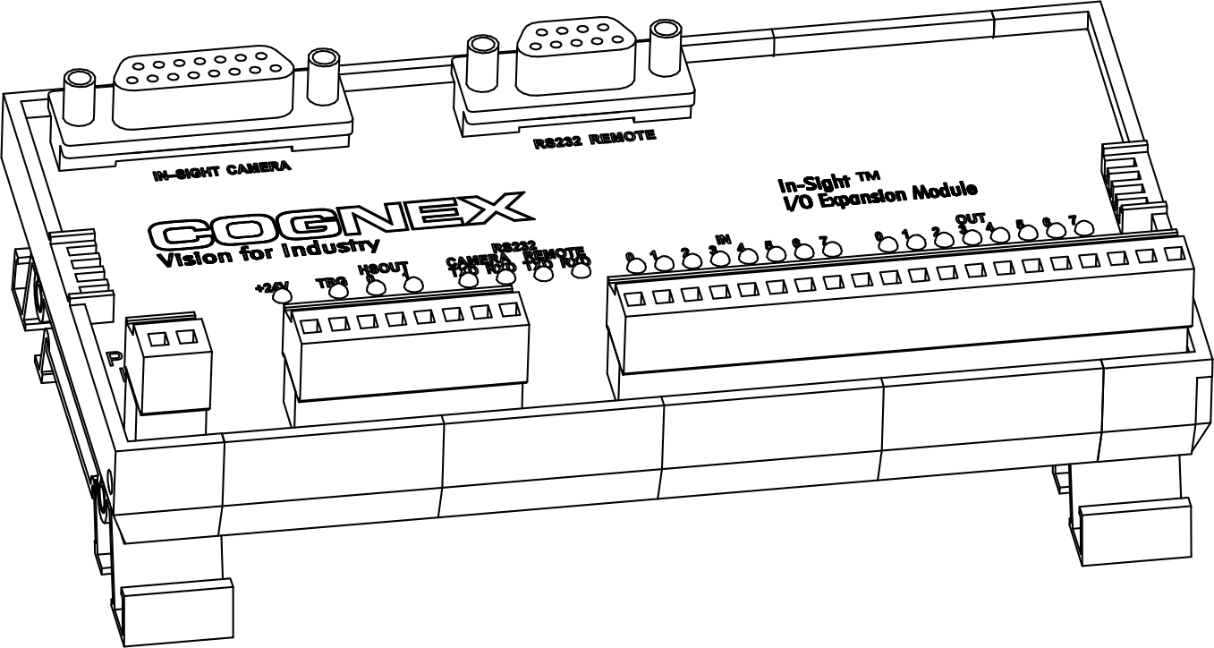

###### Figure 1-1: Model 1450 I/O Expansion Module (800-5758-1)

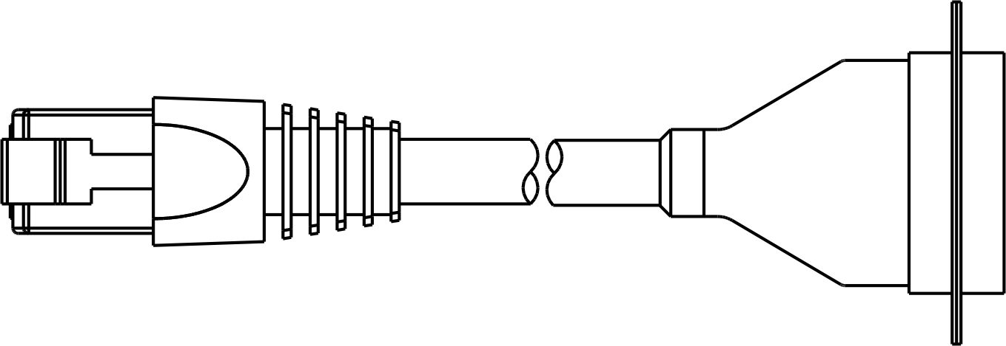

###### Figure 1-2: RJ-45 Terminated I/O Cable (300-0341-15/40)

*Model 1450 I/O Expansion Module Installation & Reference*

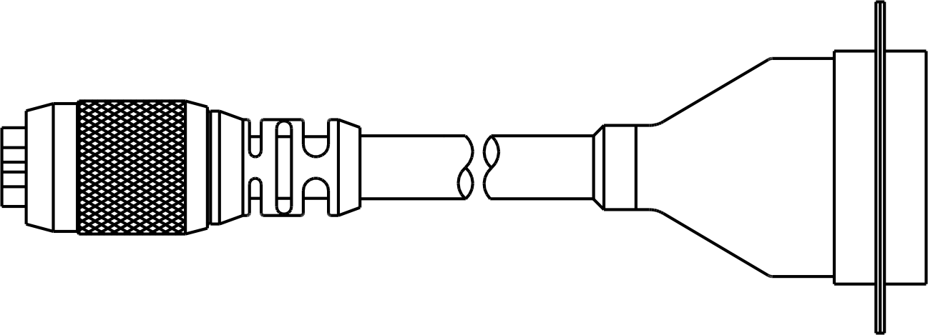

###### Figure 1-3: M12 Terminated I/O Cable, 5 M (185-0099) or 15 M (185-0091)

## In-Sight Support

Many information resources are available to assist you in using the I/O Expansion Module with In-Sight vision sensors.

* + - *Getting Started with In-Sight*, Cognex P/N 590-6368 (English), 590-6368F (French), 590-6368G (German), or 590-6368J (Japanese).
    - *In-Sight® Explorer Help,* an on-line HTML Help file provided on the In-Sight CD-ROM (for In-Sight Explorer software).
    - *In-Sight® Guide & Reference*, an on-line HTML Help file provided on the In-Sight CD-ROM (for In-Sight PC Host).
    - *Installing In-Sight® 1000 Series Vision Sensors,* Cognex P/N 597-001-xx (English), 597-0001-xxF (French), 597-0001-xxG (German).
    - *Installing In-Sight® 1700 Series Wafer Reader User Manual*
    - *Installing In-Sight® 4000 Series Vision Sensors,* Cognex P/N 597-014-xx (English), 597-0014-xxF (French).
    - *Installing In-Sight® 3400 Vision Sensors,* Cognex P/N 597-0025-xx (English), 597-0025-xxF (French), 597-0025-xxG (German).
    - *Installing In-Sight® 5000 Series Vision Sensors,* Cognex P/N 597-0027-xx (English), 597-0027-xxF (French).
    - In-Sight computer-based tutorials provided on CD-ROM with In-Sight starter accessory kits.
    - The In-Sight Online Support and Learning Center at: [www.cognex.com/support/In-Sight.asp](http://www.cognex.com/support/In-Sight.asp).

|  |
| --- |
| **NOTE** Only registered In-Sight users have access to the In-Sight Online Support and Learning Center website. |

* 1. Connecting the I/O Expansion Module 5



**2 Installation**

**In this section…**

* 1. Configuring the In-Sight Sensor 8

## Connecting the I/O Expansion Module

##### To connect an I/O Expansion Module to the In-Sight sensor:

* + 1. Verify that the 24VDC power supply is switched off.
    2. Connect the power and ground wires from remote I/O devices to terminals on the I/O Expansion Module.

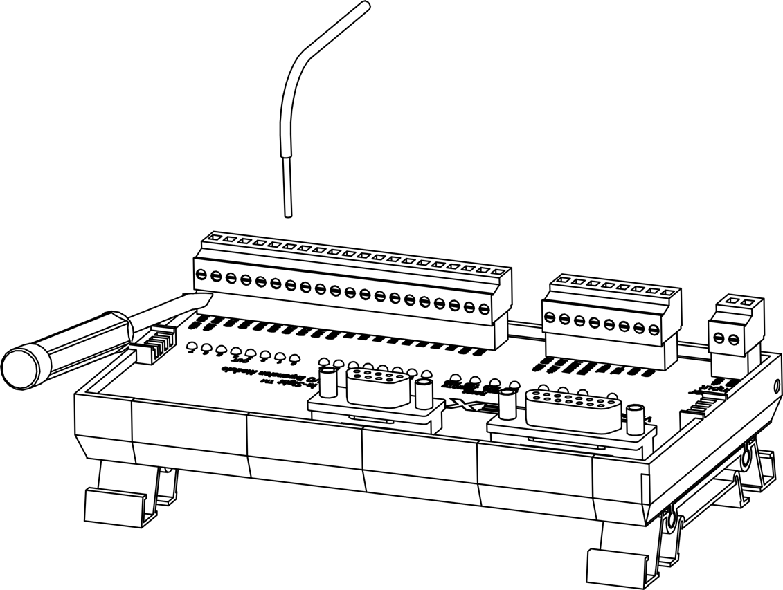

###### Figure 2-1: Connecting I/O Wires

* + - 1. Use a flat-head screwdriver to loosen the screw terminals.
      2. Insert wire leads from remote I/O devices into the appropriate positions on the terminal block. Refer to Section 3.4.3: Terminal Block Assignments on page 19 to verify the assigned signal at each position.

|  |
| --- |
| **NOTE** The I/O Expansion Module outputs labeled HSOUT0 and HSOUT1 correspond to the In-Sight  1000 series/3400/4000 series/5000 series sensor’s built-in outputs. These signals pass thru the micro- controller on the I/O Expansion Module without processing. In contrast, the general-purpose outputs labeled OUT0 through OUT7 are lower speed because the micro controller processes these signals before they are transmitted to remote devices. |

* + - 1. Tighten the screw terminals with the screwdriver to secure the wire leads in the terminal block.
    1. If the In-Sight sensor will be communicating with a remote serial device, plug the male DB9 connector into the RS-232 REMOTE connector (female DB9) on the I/O Expansion Module.
    2. Plug the male DB15 connector of the I/O Cable into the corresponding female connector on the I/O Expansion Module.

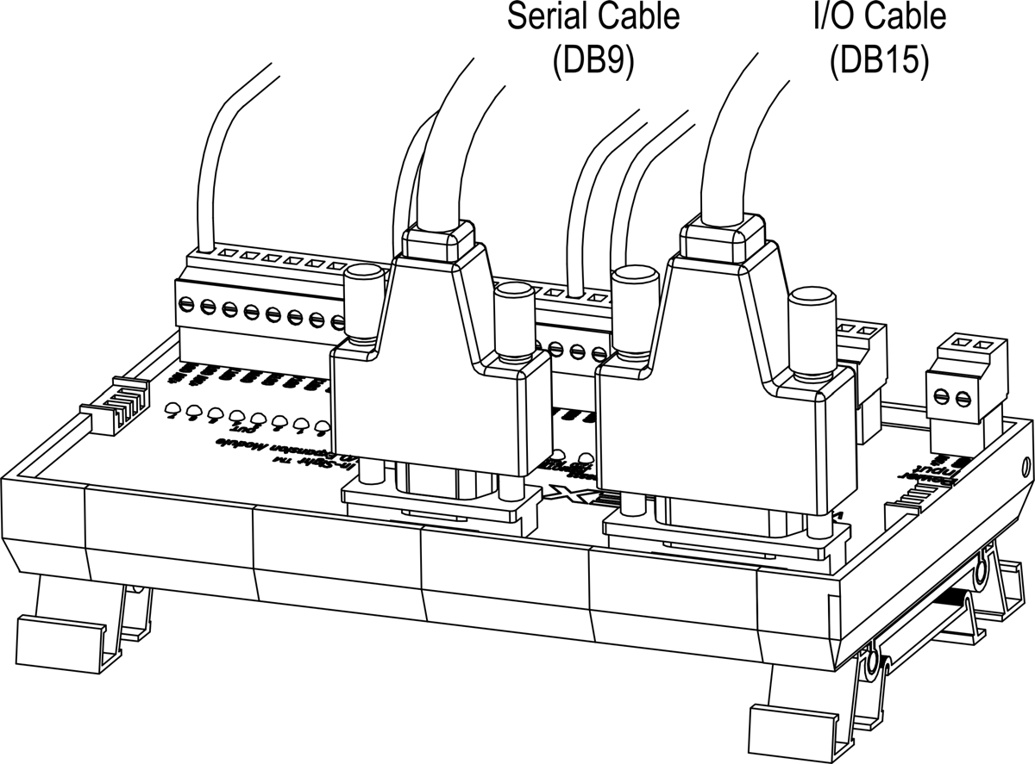

###### Figure 2-2: Connecting the I/O Cable and Serial Cable

* + 1. Connect the RJ-45 (or M12) connector of the I/O Cable into the In-Sight sensor’s breakout port (labeled 24VDC). The RJ-45 and M12 connectors are “keyed” to the applicable Breakout port.

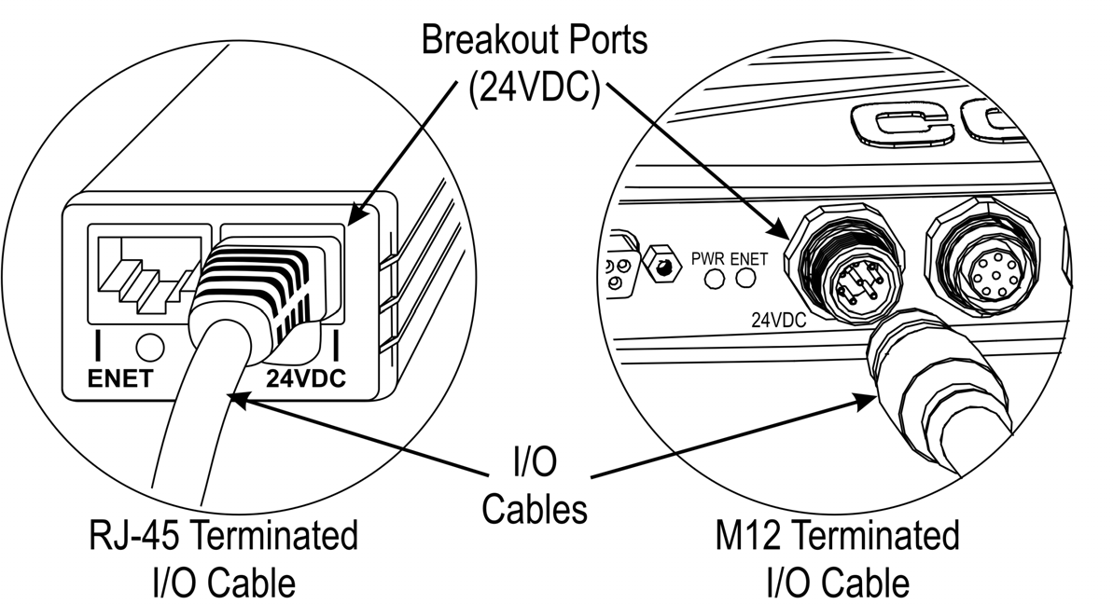

###### Figure 2-3: Connecting the Expansion Module Cable

* + 1. Insert wire leads from a 24VDC supply for the +24V power and ground into the 2-pin terminal plug labeled “Power Input” on the Expansion Module (Figure 2-4).

|  |
| --- |
| **CAUTION** Never connect the I/O Expansion Module to a power source other than 24VDC. Any other voltage creates a risk of fire or shock and can damage the hardware. Do not connect the 24VDC source to any terminals other than the two-pin 24VDC power connector. |

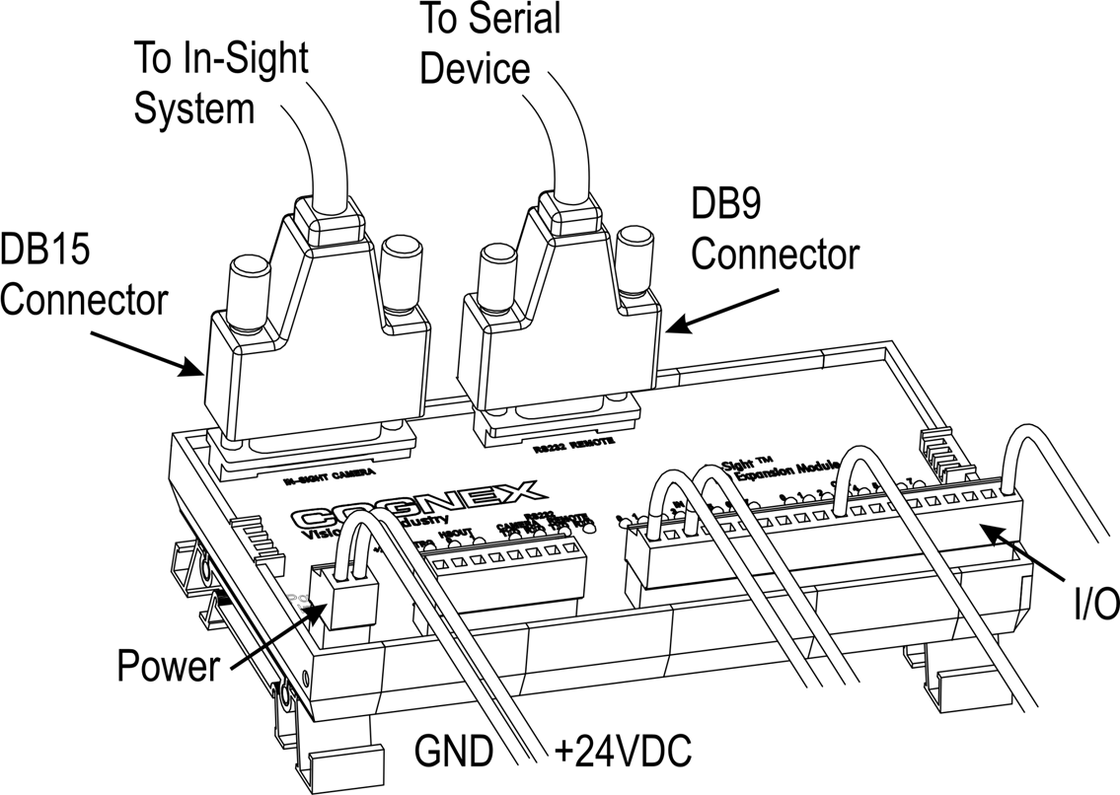

###### Figure 2-4: Connecting +24VDC and Ground Wires

* + 1. Switch on the 24VDC supply. The power LED on the In-Sight sensor and the orange

+24V LED on the Expansion Module will indicate that the sensor and Expansion Module are receiving power.

|  |
| --- |
| **NOTE** If you experience intermittent serial communication faults when using the 40-foot Expansion Module Cable (P/N 300-0341-40), replace the 40-foot cable with the 15-foot cable. If problems still occur, please contact Cognex Technical Support. |

## Configuring the In-Sight Sensor

Before the I/O Expansion Module can be used, the In-Sight sensor’s settings must be configured to recognize the availability of the additional inputs and outputs, as well as the added serial hardware handshake capability. The I/O Expansion Module may be configured using In-Sight Explorer. Refer to Appendix A on page 21 for details on configuring the I/O Expansion Module using the In-Sight 3400 embedded GUI or In-Sight PC Host.

### I/O Configuration Using In-Sight Explorer

* + - 1. Physically connect the I/O Expansion Module to the In-Sight sensor, as described previously in Section 2.1.
      2. Open the In-Sight Explorer program and log on to the sensor.
      3. From the **Device** menu, select the **Discrete I/O Settings** submenu. Select the **Output Settings** option (Figure 2-5).

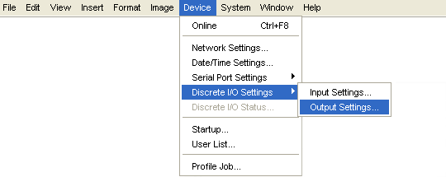

###### Figure 2-5: Accessing the I/O Output Settings

* + - 1. Open the **Output Module** drop-down list at the bottom left of the window (Figure 2-6) and select **I/O Expansion Module**. The Discrete Output window will automatically reconfigure to correspond to the I/O Expansion Module, as shown in Figure 2-6.

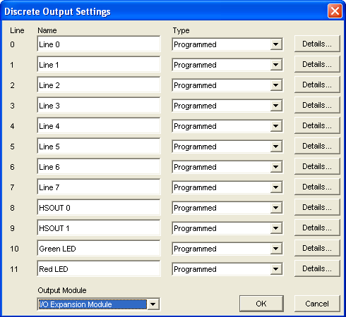

###### Figure 2-6: Discrete Output Settings

|  |
| --- |
| **NOTE** When an existing .JOB file containing a WriteDiscrete function is loaded on an In-Sight sensor to which the I/O Expansion Module has just been added, the Start Bit and Number of Bits parameters in WriteDiscrete must be changed to reflect the new configuration of the I/O lines. For example, the physical output lines 0 and 1 become lines 8 and 9 (HSOUT 0 and HSOUT 1) when the I/O Expansion Module is enabled. |

* + - 1. Select **OK** to save the new settings to the sensor’s flash RAM.

|  |
| --- |
| **NOTE** An error message will appear if the I/O Expansion Module is not attached to the In-Sight sensor, and the Discrete Output dialog will return to its default configuration. Verify that the I/O Expansion Module is connected as described in Section 2.1, then repeat steps 1 – 12 as described above. |

The sensor can also be configured to use the I/O Expansion Module by opening the Discrete Input dialog and following step 11, as described above.

Once the I/O Expansion Module is selected in either the Discrete Input or Discrete Output dialogs, it is automatically enabled for both inputs and outputs, and hardware handshaking may be used in serial communications.

### Enabling Hardware Handshaking Using In-Sight Explorer

* + - 1. From the **Device** menu (Figure 2-7), select the **Serial Port Settings** submenu. Select

###### Port 1.

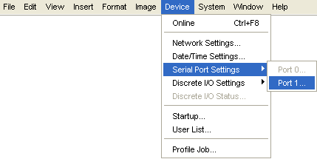

###### Figure 2-7: Accessing the Serial Port Settings

* + - 1. Select **Hardware** from the Handshake drop-down list (Figure 2-8).

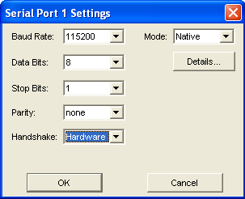

###### Figure 2-8: Serial Port Settings

Refer to the *In-Sight® Explorer Help* HTML Help file installed with In-Sight Explorer for details on using the Discrete and Serial Input/Output functions in In-Sight Explorer.

# Specifications

##### In this section…

* 1. General Specifications 11
  2. Acquisition Trigger Input 12
  3. Input and Output Specifications 14
  4. Connector and Terminal Block Specifications 18
  5. Dimensions 19

## General Specifications

###### Table 3-1: I/O Expansion Module General Specifications

|  |  |  |
| --- | --- | --- |
| **SPECIFICATION** | | **DESCRIPTION** |
| **SYSTEM COMPATIBILITY** | | In-Sight 1000 series/1700 series/3400/4000 series/5000 series. |
| **I/O** | **TRIGGER** | 1 opto-isolated, acquisition trigger input. |
| **INPUTS** | 8 discrete inputs (general-purpose). |
| **OUTPUTS** | 10 discrete outputs (2 high-speed, 8 general-purpose)  1000 series/3400/4000series/5000 series.  8 discrete outputs (general-purpose) 1700 Series Wafer Reader. |
| **COMMUNICATIONS** | **SERIAL** | 1 RS-232C port (1200 to 115,200 baud rates). RxD, TxD, and Flow control (RTS/CTS). |
| **STATUS LEDS** | | 1 each for power, acquisition trigger, inputs, and outputs. 2 each for Camera and Remote RS-232. |
| **MECHANICAL** | **HOUSING** | Black plastic. |
| **MOUNTING** | #3 DIN-rail (35 mm). |
| **DIMENSIONS** | 150 mm (5.89 in) x 83.1 mm (3.27 in) x 47.0 mm (1.85 in). |
| **TERMINAL**  **BLOCK** | 26 to 16 AWG.  Maximum torque 0.3 N-m (2.7 in-lb). |
| **WEIGHT** | 164.4 g (5.8 oz). |
| **POWER** | | 24VDC ± 10%, 1.25 Amps, 30W supply*. |
| **ENVIRONMENTAL** | **TEMPERATURE** | 0 to 50°C (operating), -10 to 65°C (storage). |
| **HUMIDITY** | 10 to 90%, non-condensing (Operating and Storage). |
| **CERTIFICATIONS** | | CE. |

* Maximum draw when I/O Expansion Module supplies power to an In-Sight 4100 sensor, and when all inputs, outputs, and LED indicators are in use. Draw will be less than 30W under typical usage.

## Acquisition Trigger Input

The I/O Expansion Module provides access to the supported vision sensor’s high-speed,

opto-isolated acquisition trigger input. Unlike the general-purpose inputs, the acquisition trigger input is wired directly to the CCD imager circuitry, bypassing the sensor’s operating system. The I/O Expansion Module’s micro-controller also monitors the acquisition trigger input.

###### Table 3-2: Acquisition Trigger Input Specifications

|  |  |
| --- | --- |
| **SPECIFICATION** | **DESCRIPTION** |
| **VOLTAGE** | ON 20 to 28V (24V nominal) |
| OFF 0 to 3V (12V nominal threshold) |
| **CURRENT** | ON 10 to 14.4mA |
| OFF <300µA |
| Resistance ~2K Ohms |
| **DELAY** | 250 µSec latency between leading edge of trigger and start of acquisition. Input pulse should be a minimum of 1 ms wide. |

|  |
| --- |
| **CAUTION** The In-Sight 1450 I/O Expansion Module +24V OUT pins are intended to supply low current in support of the I/O lines. Do not use these pins to supply power to other devices. |

|  |
| --- |
| **NOTE** Although the Trigger opto-coupler in the I/O module is a bi-directional device, the polarity of the TRG+ and TRG- terminals should be observed to enable the TRG LED. If polarity is reversed, the LED will not light, but the camera will still trigger. |

To trigger from an NPN (pull-down) type photo-detector or PLC output, connect pin 4 (TRG+) on the I/O Expansion Module’s terminal block to +24V OUT and connect pin 3 (TRG-) to the output of the detector. When the output turns ON, it pulls TRG- down to 0V, energizing the In-Sight camera trigger.

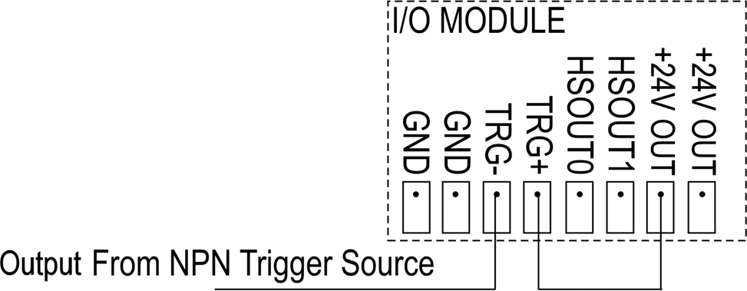

###### Figure 3-1: Acquisition Trigger Input (NPN Source)

To trigger from a PNP (pull-up) photo-detector or PLC output, connect pin 4 (TRG+) to the output of the detector and connect pin 3 (TRG-) to 0V. When the output turns ON, it pulls TRG+ up to 24V, energizing the In-Sight camera's trigger.

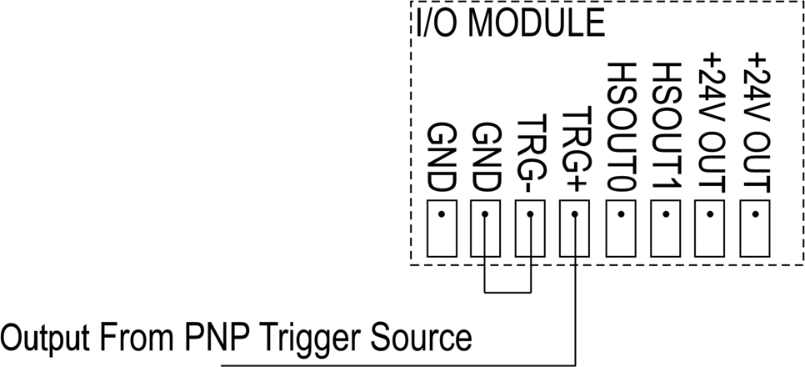

###### Figure 3-2: Acquisition Trigger Input (PNP Source)

To trigger from a differential input source, connect the negative input to pin 3 (TRG-) and the positive output to pin 4 (TRG+). When a differential voltage exists, the In-Sight camera trigger is energized.

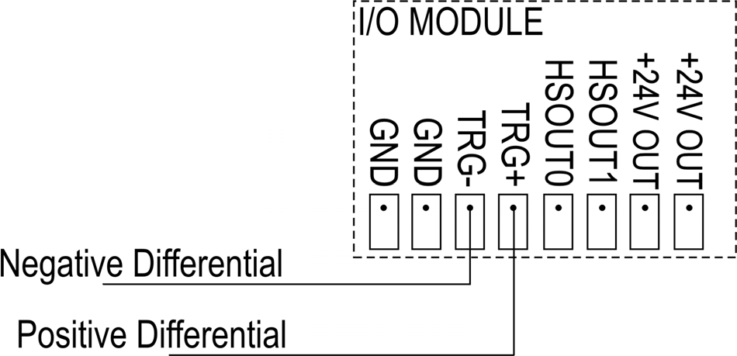

###### Figure 3-3: Acquisition Trigger Input (Differential Source)

An LED indicator is provided for the acquisition trigger and illuminates when an approximate potential of >2V is supplied across the TRG+ and TRG- terminals.

|  |
| --- |
| **NOTE** Even if the TRG LED indicator illuminates, this does not guarantee that the logical threshold has been crossed. It only means that the TRG+ and TRG- terminals are properly connected to the trigger source. |

## Input and Output Specifications

### General-Purpose Inputs

The I/O Expansion Module extends the capabilities of supported In-Sight vision sensors by providing eight independent, general-purpose inputs that can be used to trigger event execution on the sensor. LED indicators are provided on the I/O Expansion Module to indicate the state of the inputs.

|  |
| --- |
| **NOTE** The general-purpose I/O signals are approximately 1ms slower in updating and are inverse in polarity when compared to the high-speed outputs. This delay must be considered when trigger rates are faster than the required processing time. |

###### Table 3-3: General-Purpose Input Specifications

|  |  |
| --- | --- |
| **SPECIFICATION** | **DESCRIPTION** |
| **VOLTAGE** | ON 20 to 28V (24V nominal) |
| OFF 0 to 1.5V (10V nominal threshold) |
| **CURRENT** | ON 1mA to 1.3mA |
| OFF <50µA |
| Resistance ~22 K Ohms |
| **DELAY** | 600µSec max. between change of input state and completion of serial transmission to the In-Sight sensor. |

|  |
| --- |
| **CAUTION** The In-Sight 1450 I/O Expansion Module +24V OUT pins are intended to supply low current in support of the I/O lines. Do not use these pins to supply power to other devices. |

### High-Speed Outputs

In-Sight 1000 series, 3400, 4000 series and 5000 series sensors feature two built-in, high-speed discrete outputs. The I/O Expansion Module provides access to these outputs while providing an additional eight general-purpose discrete outputs that can be used to trigger remote events. The high-speed outputs are passed through the I/O module without processing.

###### Table 3-4: High-Speed Output Specifications

|  |  |
| --- | --- |
| **SPECIFICATION** | **DESCRIPTION** |
| **VOLTAGE** | 28V maximum through external load. |
| **CURRENT** | 200mA maximum sink current. |
| OFF state leakage current 100µA maximum. |
| External load resistance 120 to 10K Ohms. |
| Each line rated at a maximum 200mA, protected against over-current, short circuit, and transients from switching inductive loads. High current inductive loads require an external protection diode. |

|  |
| --- |
| **CAUTION** |
| * The In-Sight 1450 I/O Expansion Module +24V OUT pins are intended to supply low current in support of the I/O lines. Do not use these pins to supply power to other devices. |
| * High current inductive loads require an external protection diode. |

Both of the high-speed outputs are NPN (pull-down) lines. The external load should be connected between the output and the positive supply voltage (<28V). The outputs pull down to 0V when ON, which causes current to flow through the load. When the outputs are OFF, no current flows through the load.

### General-Purpose Outputs

The I/O Expansion Module extends the capabilities of supported In-Sight vision sensors by providing eight general-purpose discrete outputs that can be used to trigger remote events from supported In-Sight vision sensors.

|  |
| --- |
| **NOTE** The general-purpose I/O signals are approximately 1ms slower in updating and are inverse in polarity when compared to the high-speed outputs. This delay must be considered when trigger rates exceed the required processing time. |

###### Table 3-5: Output Specifications

|  |  |
| --- | --- |
| **SPECIFICATION** | **DESCRIPTION** |
| **VOLTAGE** | +24VDC (28V maximum through external load) |
| **CURRENT** | Maximum 150mA (sinking) / Maximum 1mA (sourcing) |
| **DELAY** | Pulse mode 1mSec max. Set/Reset mode 801µSec max. |

|  |
| --- |
| **CAUTION** |
| * The In-Sight 1450 I/O Expansion Module +24V OUT pins are intended to supply low current in support of the I/O lines. Do not use these pins to supply power to other devices. |
| * High current inductive loads require an external protection diode. |

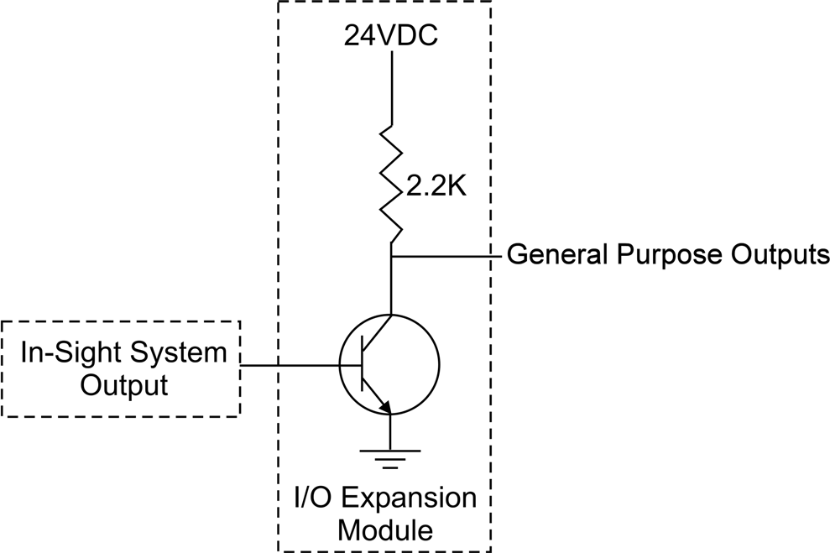

###### Figure 3-4: General-Purpose Outputs

The general-purpose outputs are NPN (sinking) outputs, but the logic is inverted. Therefore, when the In-Sight sensor is ON, the outputs are pulled up to 24VDC via a 2.2K internal resistor and the I/O module’s internal transistor is OFF. When the In-Sight sensor is OFF, the outputs are pulled to ground (0V) and the I/O module’s internal transistor is ON.

Table 3-6 provides a matrix of functionality, and use and state parameters for the I/O Expansion Module general-purpose outputs.

###### Table 3-6: General-Purpose Output Functionality

|  |  |  |  |  |
| --- | --- | --- | --- | --- |
| **IN-SIGHT WRITE DISCRETE INSTRUCTION** | **GENERAL PURPOSE OUTPUT TRANSISTOR** | **OUTPUT BEHAVIOR** | **GENERAL-PURPOSE OUTPUT WIRED FOR SINK MODE** | **GENERAL-PURPOSE OUTPUT WIRED FOR SOURCE MODE** |
| OFF = 0 | General-purpose output transistor is ON. | The output is low. | Output @ 0VDC. LED is OFF.  LOAD is ENERGIZED.  150 mA Max. | Output @ 0VDC. LED is OFF.  LOAD is DE-ENERGIZED.  1 mA Max. |
| ON = 1 | General-purpose output transistor is OFF. | The output is high through the 2.2K internal resistor. | Output @ 24VDC. LED is ON.  LOAD is DE-ENERGIZED.  150 mA Max. | Output @ 24VDC. LED is ON.  LOAD is ENERGIZED.  1 mA Max. |
| USE for Loads |  |  | Small Relays. Pilot Lights. 150 mA Max. | High Impedance Inputs. PLC Inputs.  Opto Relays. 1 mA Max. |

## Connector and Terminal Block Specifications

### RS-232 Remote Connector

The RS-232 Remote connector transmits serial data between the I/O Expansion Module and a remote device. Status LEDs are provided for the TxD and RxD lines on this port. These LEDs will illuminate only when there is activity on the associated line. Table 3-7 identifies the signal assignment for each pin on the RS-232 Remote connector.

###### Table 3-7: RS-232 Remote Connector Pin Assignments

|  |  |  |  |  |  |
| --- | --- | --- | --- | --- | --- |
|  | | | | | |
| **PIN #** | **ASSIGNMENT** | **PIN #** | **ASSIGNMENT** | **PIN #** | **ASSIGNMENT** |
| 1 | No Connect | 4 | No Connect | 7 | CTS |
| 2 | TxD | 5 | GND | 8 | RTS |
| 3 | RxD | 6 | No Connect | 9 | No Connect |

### In-Sight Camera Connector

The In-Sight Camera connector transmits discrete I/O and serial data between the sensor and the I/O Expansion Module, as well as supplying power to the sensor. Status LEDs are provided for the TxD and RxD lines on this port. These LEDs will illuminate only when there is activity on the associated line. Table 3-8 shows the signal assignments for each pin on the In-Sight Camera connector.

###### Table 3-8: In-Sight Camera Connector Pin Assignments

|  |  |  |  |  |  |
| --- | --- | --- | --- | --- | --- |
|  | | | | | |
| **PIN #** | **ASSIGNMENT** | **PIN #** | **ASSIGNMENT** | **PIN #** | **ASSIGNMENT** |
| 1 | +24VDC | 6 | RxD | 11 | GND |
| 2 | TRG + | 7 | TxD | 12 | GND |
| 3 | TRG – | 8 | GND | 13 | GND |
| 4 | High-Speed Output 0 | 9 | GND | 14 | GND |
| 5 | High-Speed Output 1 | 10 | GND | 15 | GND |

### Terminal Block Assignments

Table 3-9 shows the signal assignments for each screw terminal on the Expansion Module’s terminal blocks.

###### Table 3-9: Terminal Block Pin Assignments

|  |  |  |  |  |  |
| --- | --- | --- | --- | --- | --- |
|  | | | | | |
| **PIN #** | **ASSIGNMENT** | **PIN #** | **ASSIGNMENT** | **PIN #** | **ASSIGNMENT** |
| 1 | Ground | 11 | Ground | 21 | Output 0 |
| 2 | +24VDC | 12 | Ground | 22 | Output 1 |
| 3 | Ground | 13 | Input 0 | 23 | Output 2 |
| 4 | Ground | 14 | Input 1 | 24 | Output 3 |
| 5 | Trigger – | 15 | Input 2 | 25 | Output 4 |
| 6 | Trigger + | 16 | Input 3 | 26 | Output 5 |
| 7 | High Speed Output 0 | 17 | Input 4 | 27 | Output 6 |
| 8 | High Speed Output 1 | 18 | Input 5 | 28 | Output 7 |
| 9 | +24VDC | 19 | Input 6 | 29 | +24VDC |
| 10 | +24VDC | 20 | Input 7 | 30 | +24VDC |

## Dimensions

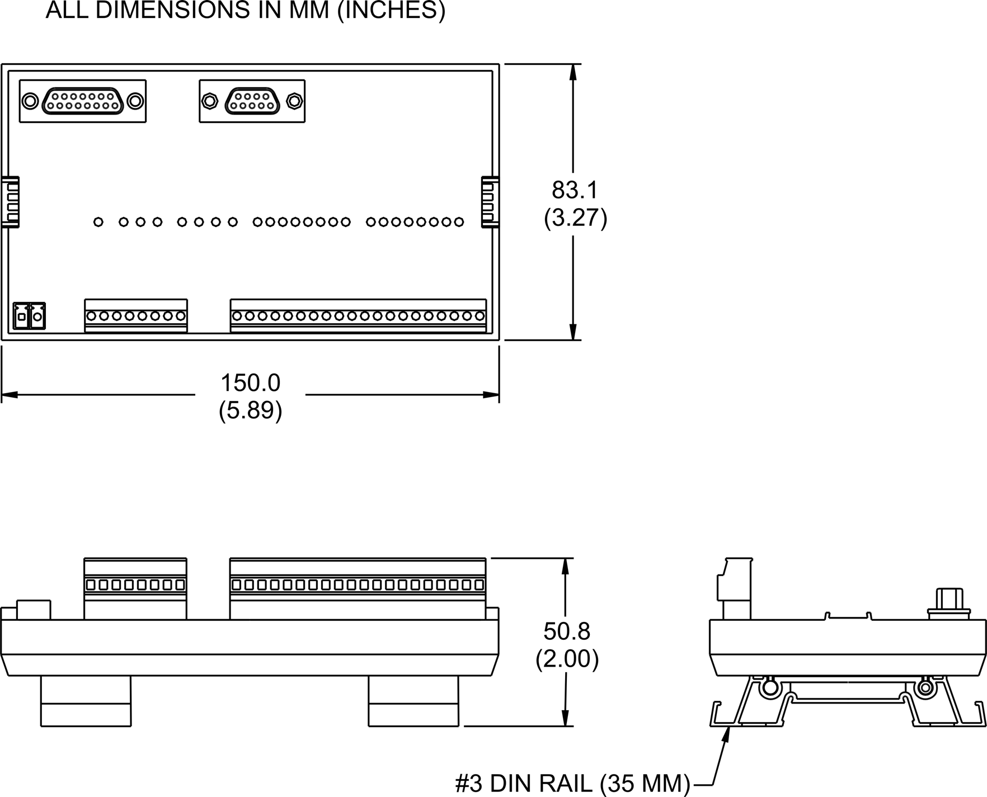

###### Figure 3-5: I/O Expansion Module Dimensions



**Appendix A**

**A.1 Configuring the Expansion Module Using the In-Sight 3400 Embedded GUI or PC Host**

As mentioned, before the Model 1450 I/O Expansion Module can be used, the In-Sight sensor's settings must be configured to recognize the availability of the additional inputs and outputs, as well as the added serial hardware handshake capability. The 1450 I/O Expansion Module may be configured using the 3400 Embedded GUI or In-Sight PC Host software.

1. Physically connect the I/O Expansion Module to the In-Sight sensor, as described previously in Section 2.1.
2. Open the In-Sight PC Host program and log on to the sensor.
3. Open the System menu (Figure A-1).

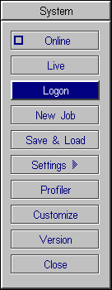

###### Figure A-1: System Menu

1. Select Settings to open the Settings menu (Figure A-2).

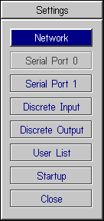

###### Figure A-2: Settings Menu

1. Select Discrete Output to open the Discrete Output dialog (Figure A-3).

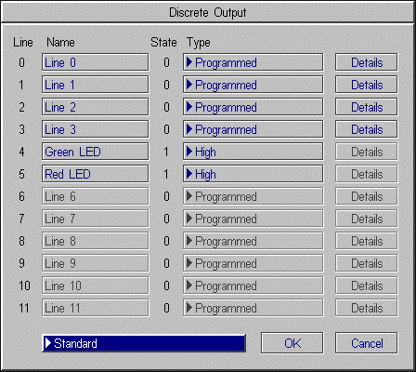

###### Figure A-3: Discrete Output Dialog, Default Configuration

*Model 1450 I/O Expansion Module Installation & Reference*

1. Open the drop-down list to the left of the OK button and select I/O Expansion Module. The Discrete Output dialog will automatically reconfigure to correspond to the I/O Expansion Module, as shown in Figure A-4.
2. Configure the Line Name, Type and Details as required.

|  |
| --- |
| **NOTE** When an existing .JOB file containing a WriteDiscrete function is loaded on an In-Sight sensor to which the I/O Expansion Module has just been added, the Start Bit and Number of Bits parameters in WriteDiscrete must be changed to reflect the new configuration of the I/O lines. For example, the physical output lines 0 and 1 become lines 8 and 9 (HSOUT0 and HSOUT1) when the I/O Expansion Module is enabled. |

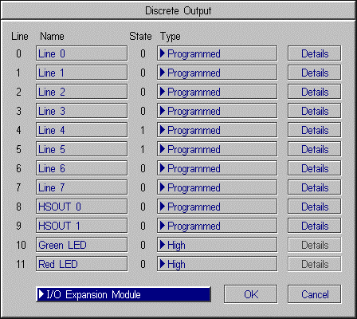

###### Figure A-4: Discrete Output Dialog, I/O Expansion Configuration

1. Select OK to save the new settings to the sensor’s flash RAM.

|  |
| --- |
| **NOTE** An error message will appear if the I/O Expansion Module is not attached to the In-Sight sensor, and the Discrete Output dialog will return to its default configuration. Verify that the I/O Expansion Module is connected as described in Section 2.1, then repeat steps 1 – 8 as described above. |

The sensor can also be configured to use the I/O Expansion Module by opening the Discrete Input dialog and following steps 6 - 8, as described above.

Once the I/O Expansion Module is selected in either the Discrete Input or Discrete Output dialogs, it is automatically enabled for both inputs and outputs, and hardware handshaking may be used in serial communications.

## Enabling Hardware Handshaking Using the In-Sight 3400 Embedded GUI or PC Host

* + 1. Open the System menu.
    2. Select Settings to open the Settings menu.
    3. Select Serial Port 1 to open the Serial Port 1 dialog (Figure A-5).

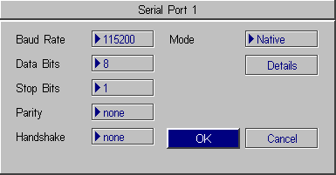

###### Figure A-5: Serial Port Dialog

* + 1. Select Hardware from the Handshake drop-down list (Figure A-6).

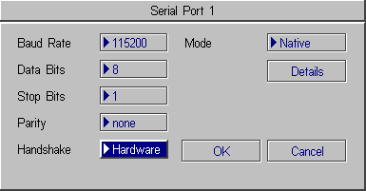

###### Figure A-6: Serial Port Dialog, Hardware Handshaking Enabled

Refer to the *In-Sight® Guide and Reference* HTML Help file for details on using the Discrete and Serial Input/Output functions in the In-Sight spreadsheet.



**Appendix B**

**B.1 Wiring Inputs and Outputs**

The following figures show basic wiring for some of the more common configurations.

### 1450 I/O Expansion Module General-Purpose Input from PLC Sourcing Output

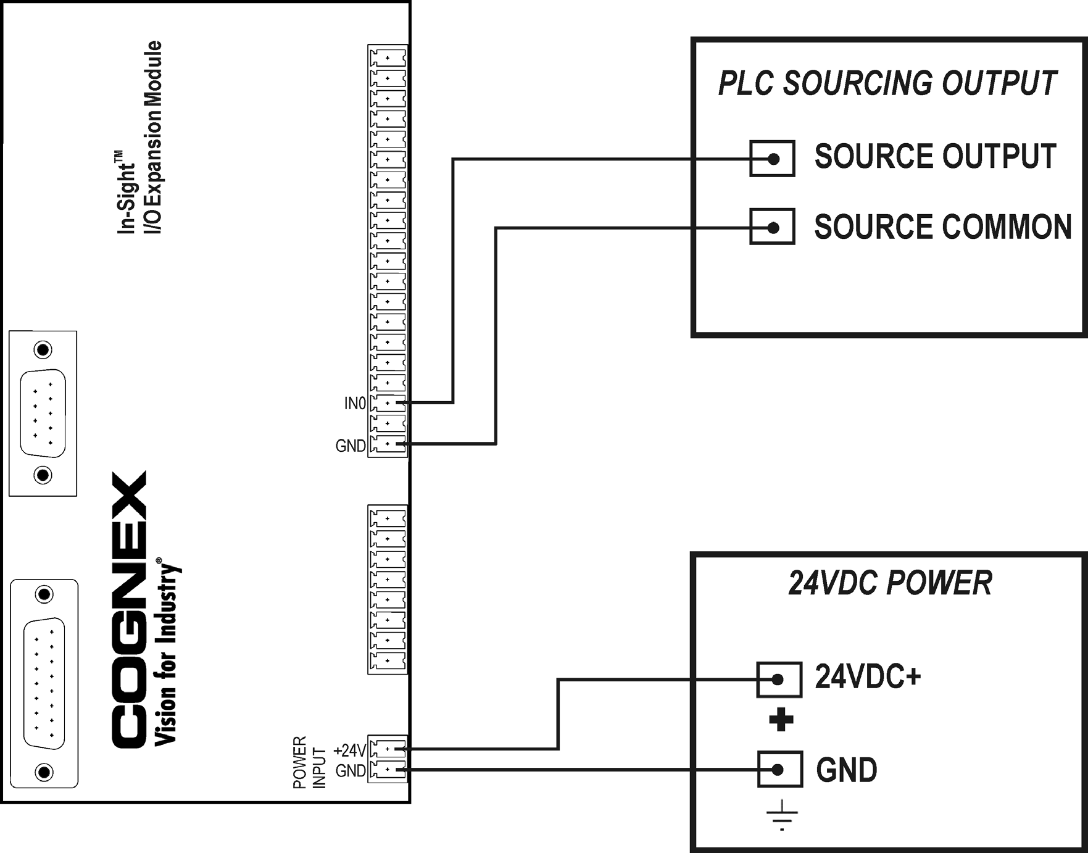

### 1450 I/O Expansion Module General-Purpose Input from PLC Sinking Output

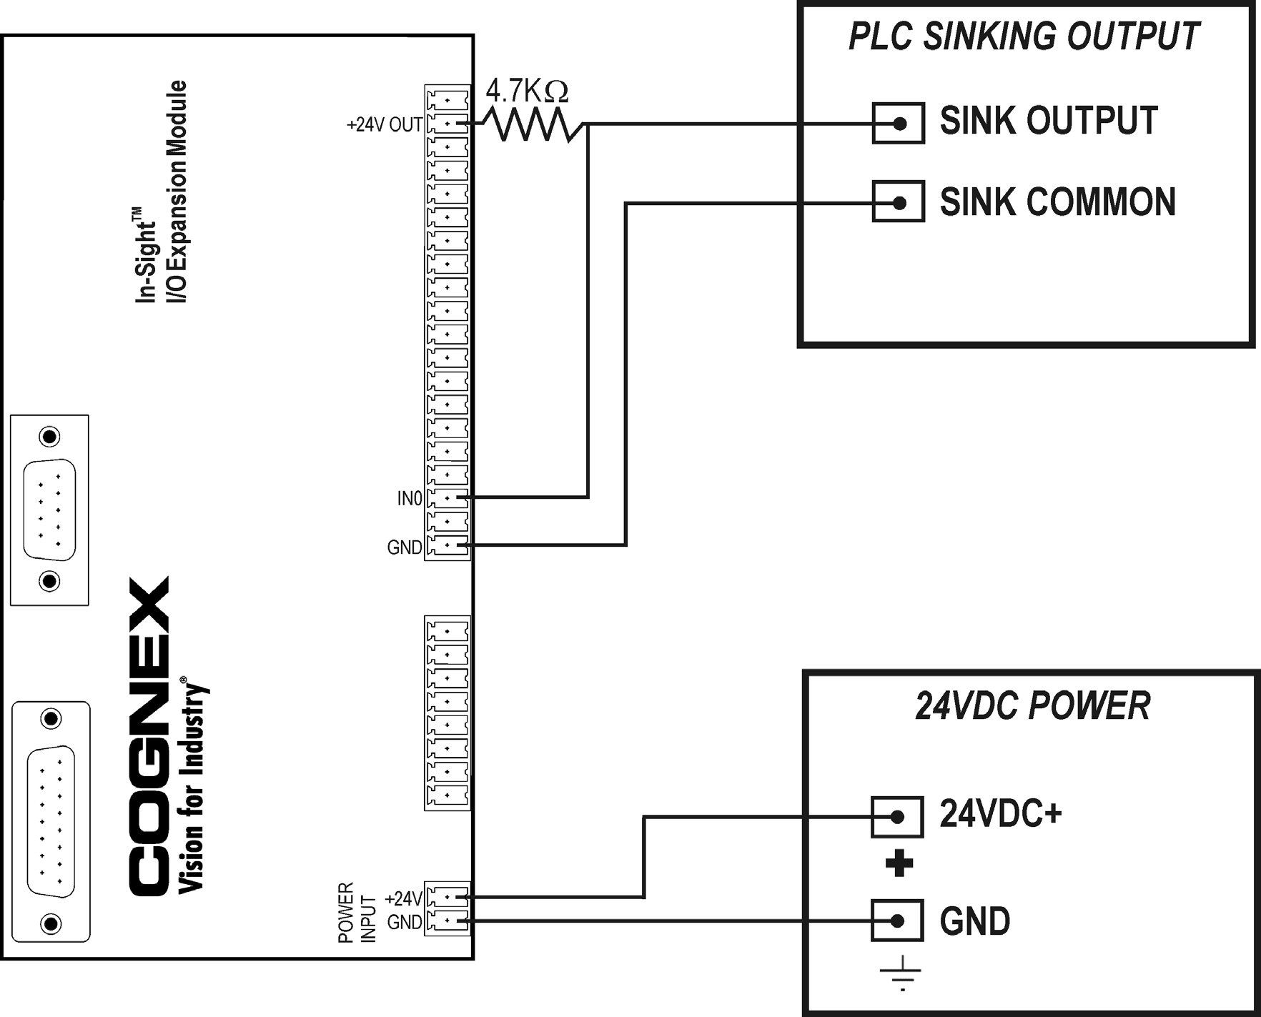

The general-purpose inputs can also be triggered from PLC outputs by connecting an additional, external resistor (for example, 4.7K Ohms 0.25W) from a +24V OUT terminal on the I/O Expansion Module to the input. In this case, the resistor supplies 24V to the input. The PLC output will pull the voltage down to 0V, deactivating the input. This creates an inversion with the input OFF when the PLC output is ON, and vice-versa. The sense of the input can be changed using the In-Sight software.

LED indicators are provided on the I/O Expansion Module to indicate the status of the inputs. The LED indicators will illuminate when the inputs are actively pulled high, either by the source or the added pull-up resistor.

### 1450 I/O Expansion Module High-Speed Output to PLC Sinking Input

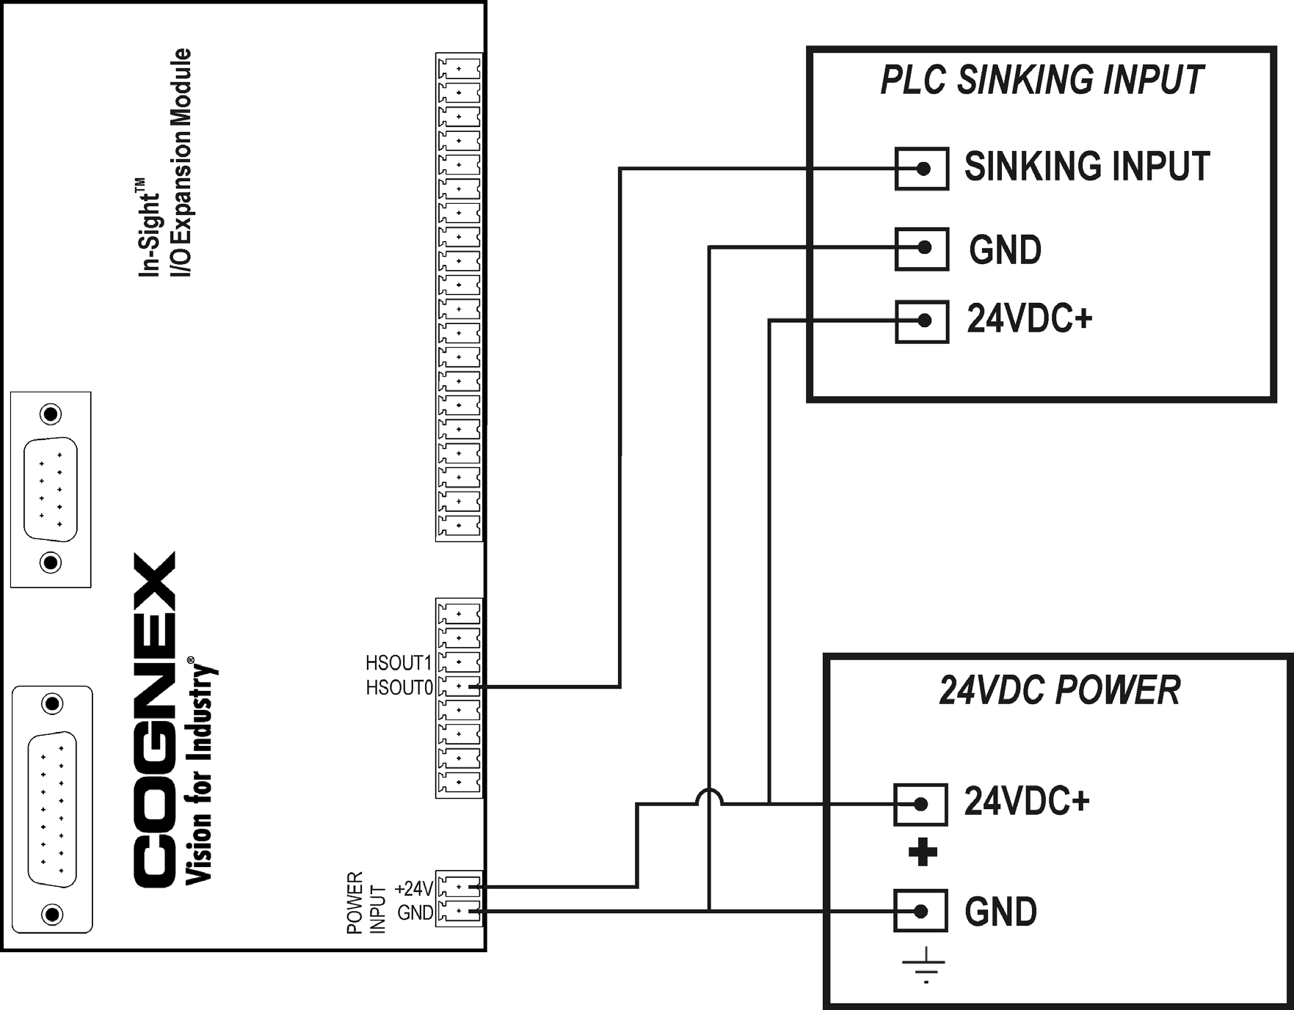

### 1450 I/O Expansion Module High-Speed Output to PLC Sourcing Input

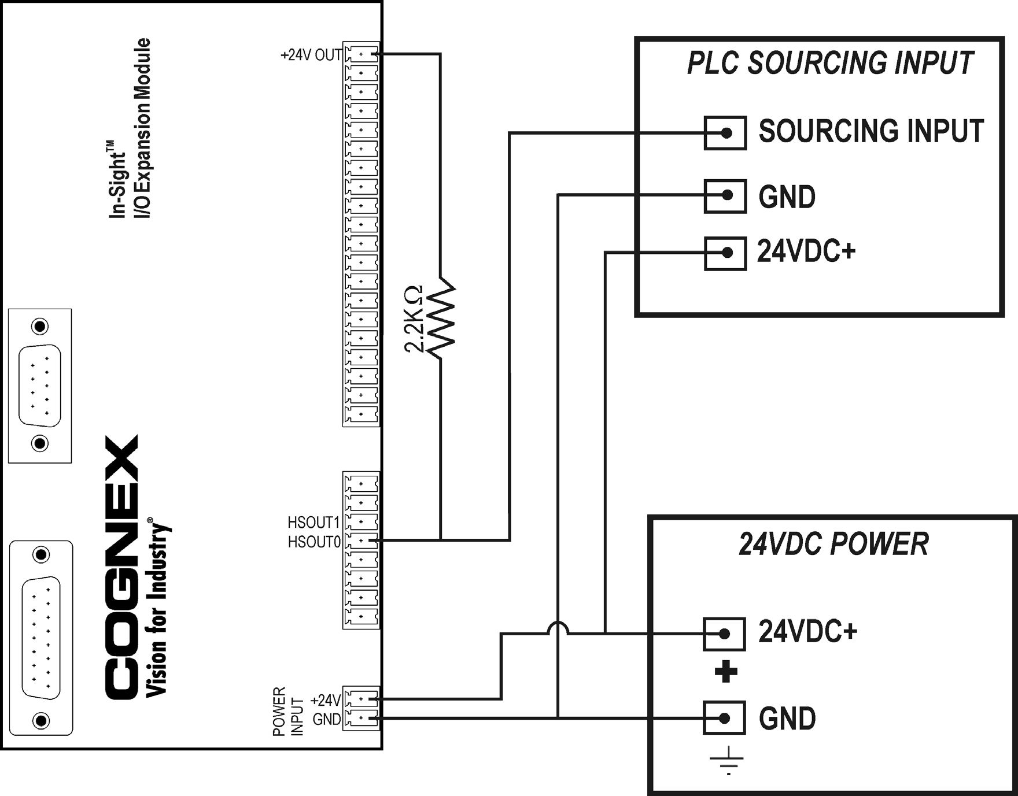

High-speed outputs can also be used with a PNP-compatible PLC input if a pull-up resistor (for example, 2.2K Ohm 0.5W) is connected from the high-speed output to a +24V OUT terminal on the I/O Expansion Module. In this case, the resistor supplies 24V to the PLC input. The output will pull the voltage down to 0V, turning off the PLC input. This creates an inversion, with the PLC input ON when the In-Sight output is OFF, and vice-versa. Use an external NPN to PNP converter when this inversion is not desired.

Status LEDs on the I/O Expansion Module indicate the state of the outputs. In the case of the two high-speed outputs, the LEDs will illuminate when the outputs are actively pulled low.

### 1450 I/O Expansion Module High-Speed Output to Pilot Light

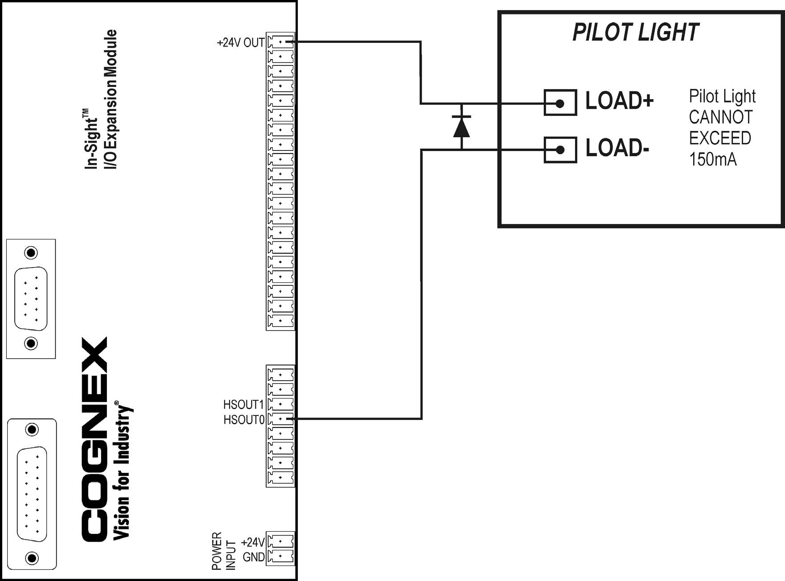

|  |
| --- |
| **CAUTION** High current inductive loads require an external protection diode. |

### 1450 I/O Expansion Module General-Purpose Output to PLC Sinking Input

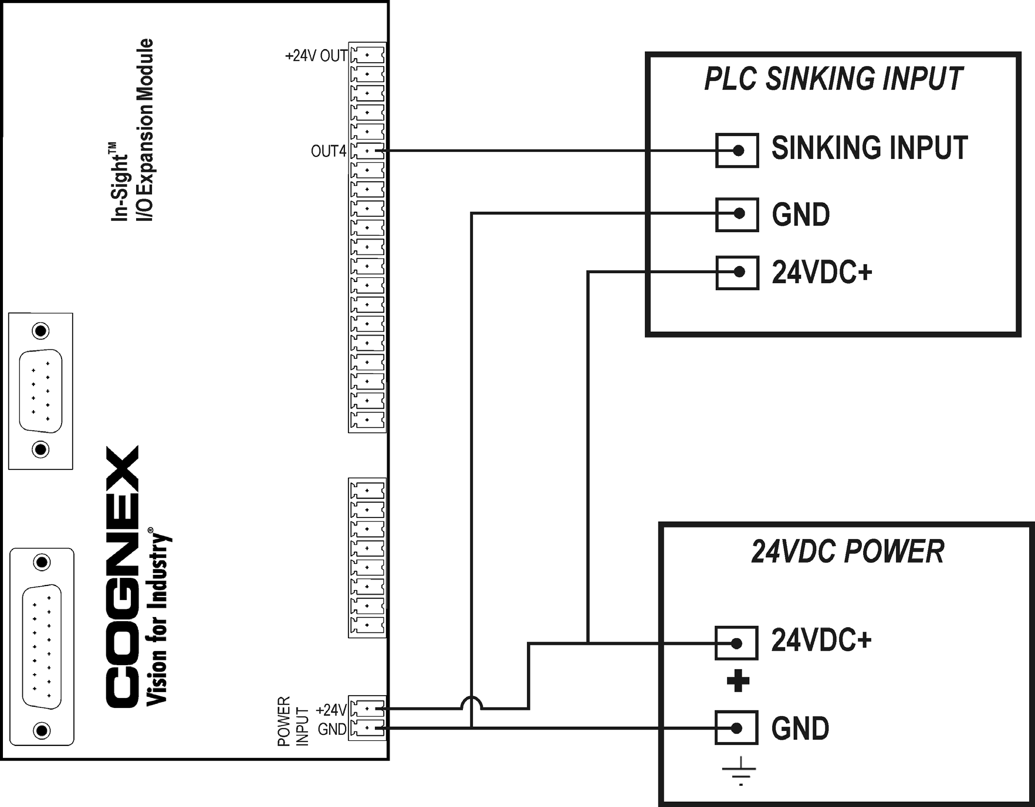

### 1450 I/O Expansion Module General-Purpose Output to PLC Sourcing Input

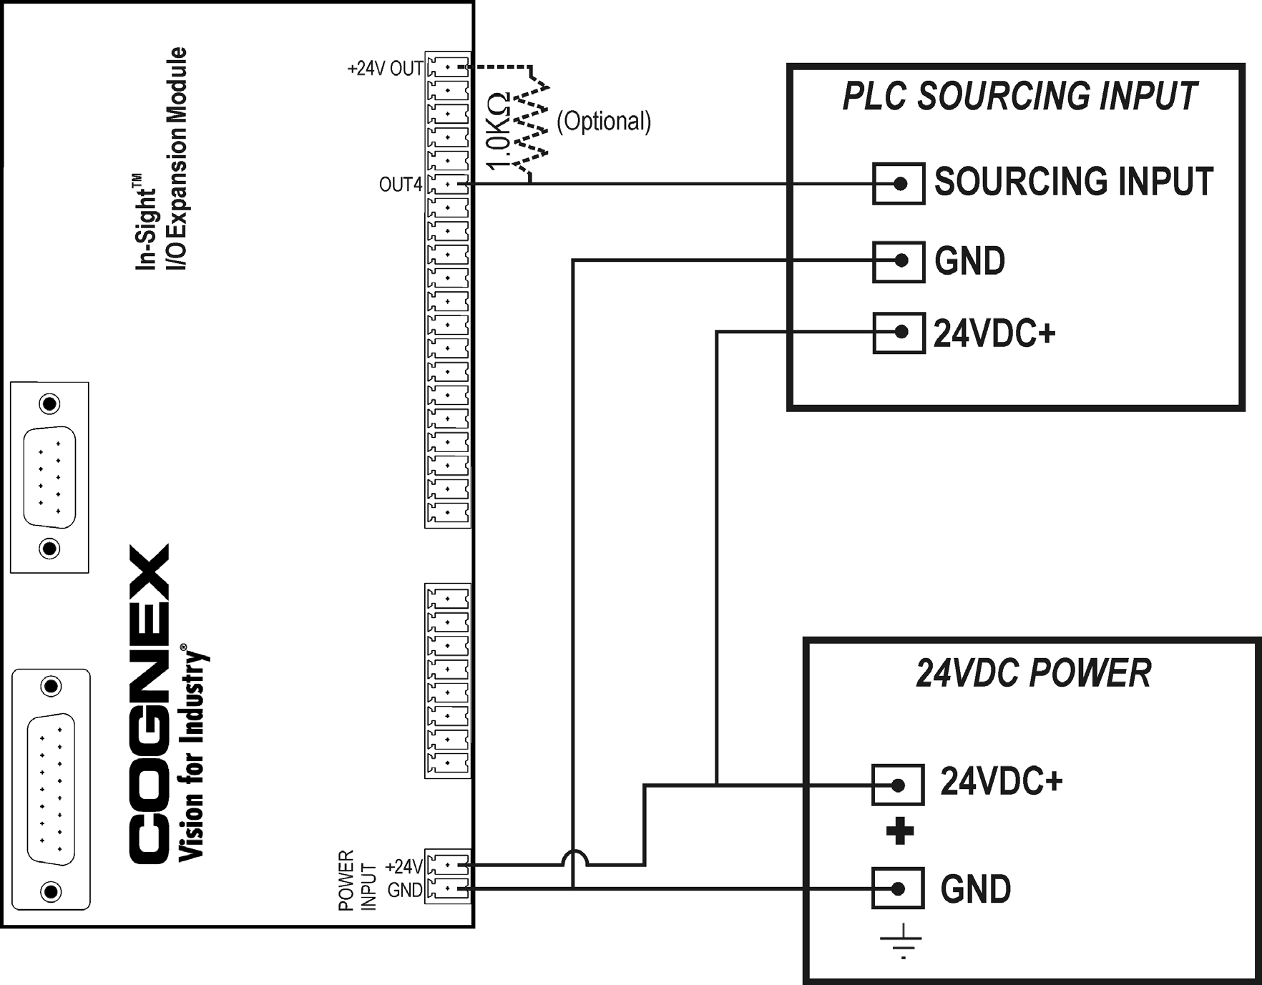

The Model 1450 I/O Module provides 1mA of source current. If more current is required, a 1.0K Ohm 1W pull-up resistor can be added; connect one end of the resistor to the output and the other end to a +24V OUT terminal on the I/O Expansion Module.

The corresponding LEDs will illuminate only when the outputs are activated in the pulled-up state.

|  |
| --- |
| **NOTE** The status LEDs for general-purpose outputs will illuminate even in the sourcing input case, where the output is activated but the load does not detect a high (i.e., the pull-up resistor is not sufficient to overcome the load resistance to ground). This is because the LED indicator is driven from the logic source at the micro-controller and not connected directly to the load. |

### 1450 I/O Expansion Module General-Purpose Output to Pilot Light

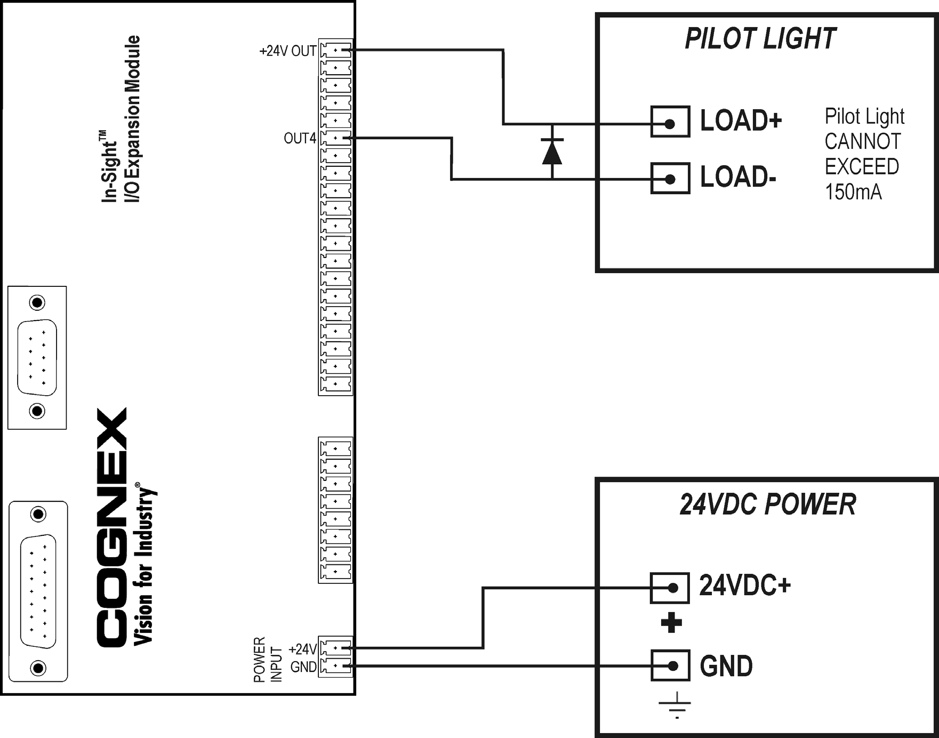

|  |
| --- |
| **CAUTION** High current inductive loads require an external protection diode. |

|  |
| --- |
| **NOTE** When the General-Purpose Output is wired for sink mode, the In-Sight logic is inverted. Therefore, when the In-Sight Write Discrete function is OFF, the load is energized. |

### 1450 I/O Expansion Module General-Purpose Output to Relay Coil

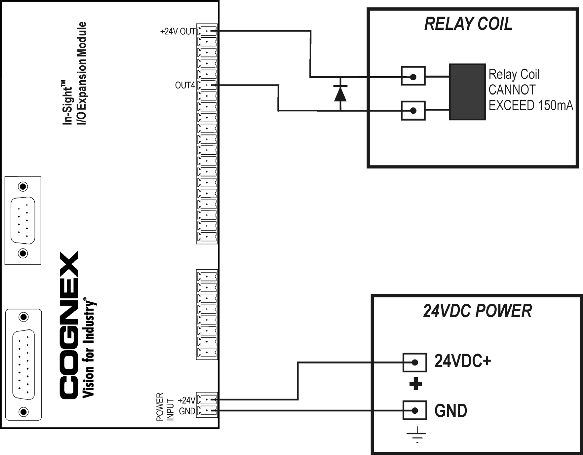

|  |
| --- |
| **CAUTION** High current inductive loads require an external protection diode. |

|  |
| --- |
| **NOTE** When the General-Purpose Output is wired for sink mode, the In-Sight logic is inverted. Therefore, when the In-Sight Write Discrete function is OFF, the load is energized. |



#### In-Sight® Model 1450 I/O Expansion Module Installation and Reference



[**www.cognex.com**](http://www.cognex.com/) **P/N 597-0013-05**